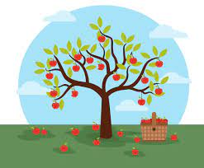

Appendix 2

Small Community Orchards (Fruit & Nut)
Trees should be Irish grown and supplied. All trees should be purchased from a reputable nursery and details of supplier, plant passport, species, variety and location of planting when project is complete must be provided to the council’s parks department.
Design: As a rule, fruit and nut trees generally prefer a sunny, sheltered, free draining spot with a deep, fertile, loamy soil and protection from cold winds and winter frosts. Give them a frost pocket and a poor, wet soil and they’ll almost invariably repay you by dying. Be kind. Know your site!
Trees grown in north-south oriented rows have better light conditions than those grown in east-west rows.
The number of trees will depend on the size you want to grow, (See rootstock below). The area given to an orchard should not affect the amenity of other users for example if the area is regularly used by children playing ball games this will not be considered. Make sure the community are on board and supportive of this project, canvas, put up neighbourhood signs and get feedback. Don’t go too big too soon, maybe 10 medium trees would make a good start, and more can be added over time. But this will be determined by costs of your project (remember to include stakes, ties, mulch, soil amendments in your costing).
Tree selection
As much as it is worth considering your location, it is equally as important to choose your trees wisely. The following hints should help you make the correct decision. Remember to talk to your tree supplier to confirm your choices, they are there to help.
Rootstock
Newly planted orchard Fruit trees are supplied on different rootstocks. Rootstocks give a predictable growth rate and structure and mean that fruit trees can be planted in most situations if the appropriate rootstock is selected.
Rootstocks vary from extremely dwarfing to extremely vigorous, and so the resulting mature tree will be a predicted height; very small ranging to very large. There are advantages and disadvantages of the uses of different rootstocks.
Dwarfing ones are easy to prune and harvest from but have a poor root system meaning they require staking all of their life. Vigorous rootstocks lead to large trees which are difficult to harvest from and prune (tall), however they will develop strong roots and will be more hardy to adverse weather conditions.
The rootstock chosen will obviously influence how widely the trees need to be planted apart and how large the trees will eventually become. The table below gives examples of different rootstocks, however many more are available, depends on supplier but something in-between would be recommended.
A selection of rootstocks and their characteristics
Fruit type | Rootstock name | Final tree height | Spacing | Time until good crop produced | Notes
Apple | M25 (extremely vigerous) | 6m+ | 10m | 5 - 7 years | Favoured in traditional orchards to produce large standard trees. Staking required only in first few years.
Apple | MM106 (semi-dwarfing) | 4m | 4m | 3 - 4 years | Good all rounder, favoured for the 'garden orchard'. Staking required only in the first few years, but permanently if on poorer soil.
Apple | M27 (extremely dwarfing) | 2m | 1.5m | 2 years | A dwarf tree suitable for small spaces and containers. Will need permanent staking.
Apple | M9 (dwarfing) | 2.5 - 3m | 2.5 – 3m | 2-3yrs | A dwarf tree suitable for high density orchards, urban gardens. Will need permanent staking.
Pear | Quince A (semi vigerous) | 5m | 5m | 4 years | Suitable for most garden soils. Will need permanent staking.
Cherry | Colt (semi-vigorous) | 6m | 6m | 3 years | Suitable for most garden soils. Will need permanent staking.
*recommend MM106 or something similar. Less recommended are dwarfing rootstocks for this grant, they produce fruit fast but require regular pruning maintenance and will never be climbed. Permanently staked. Supply can depend on nursery/pre-ordering/time.
The smaller the spacing the more pruning required, to keep them small. Larger spacings can make the orchard seem sparse when they are young, but they will fill up this space over the years.
More information is available online, for example: https://www.rhs.org.uk/advice/profile?pid=359
https://irishseedsavers.ie/product/creating-an-orchard-sunday-june-20th/

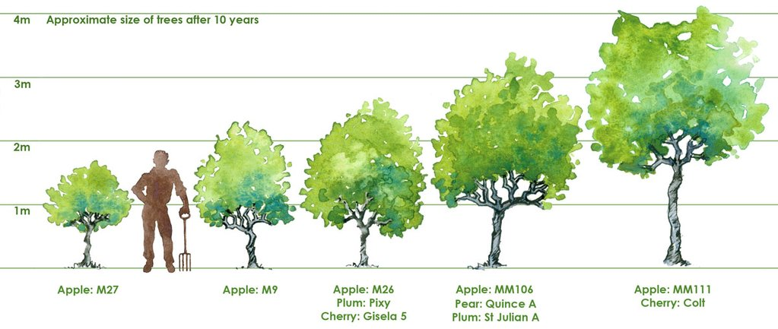
Varieties
Which varieties you go for entirely depend on what you want to get out of your orchard, whether it is for cider or for kitchen use. The only constricting factor with varieties is whether you need to choose later blossoming ones if your site is very exposed. Whenever possible plant at least some traditional, local varieties to your area. Traditional varieties are in danger of being lost as more modern ones are chosen in preference.
Pollination
Many fruit trees are what we call ‘self-sterile’ that is they require another variety to be present for pollination to occur so fruit is produced. The other option is ‘self-fertile’ trees, i.e. those trees which produce fruit with or without any pollination from another tree. Even self-fertile trees benefit from some pollination as this can improve yields. Fruit trees are categorised into ‘pollination groups’ based on when they come into flower. Fruit trees can only be pollinated by varieties in the same group as them, or the next one up or down. In other words, group 2 trees can be pollinated by groups 1, 2 and 3 but not 4.
Most self-sterile trees are ‘diploid’ that is, they only require one other variety for pollination. Some however, are trickier and are called ‘triploid’. Triploid trees require at least two other varieties in the same pollination group to ensure a crop of fruit.
The pollination requirements of a fruit tree should be on the tree label. (If not, simply put, the different varieties must be in flower at the same time.)
Planting
After making all of your important decisions on where to plant your trees and which ones to plant, there is then the task of actually planting them.
Example planting space between trees:
MM111 planting space 4-5m
MM106 4 – 4.5m
M9 1.5m
Stakes and guards
All fruit trees will require staking for some amount of time after planting. The type of stake required and also the guards you use to protect the tree will depend upon what else you will use the orchard space for. If you intend to graze the orchard, heavy duty stakes and guards will have to be used as most sheep, cattle and horses will destroy an orchard of young fruit trees within minutes, if the trees are not protected. If no grazing is expected, a rabbit guard and small stake will be sufficient while the tree establishes itself.
Planting the trees
The tree should not have its roots exposed (either from the plastic wrapping or planting pot) until the very last minute before they go into the hole. Tree roots are damaged within seconds of being exposed to the air as they dry out so quickly. This is a job for two people. Make the planting hole generously wide and a little deeper than the tree’s original planting depth. You will be able to see the old soil line on the tree itself and should be a few centimetres below the graft line (where the rootstock and variety have been joined).
Add a small amount of manure/ garden compost if the soil is poor and work it well into the loose soil.
You could also add some dried organic fertiliser or mycorrhizal fungi (from good garden centres). Soak the root ball in water for a few minutes and then place in the hole, spreading the bare roots onto a gentle mound of earth and positioning the tree so that the original soil mark is just above ground level.
The stake should be driven into the ground before the tree goes in so that the tree roots may be arranged around the stake, minimising damage to the roots. Make sure that the stake is to the windward side. It should project at least 30cm out of the ground, vertically, and should sit around 15cm away from the tree trunk.
Once the tree has been placed in the hole the soil should be carefully placed in whilst the tree is kept vertical. Backfill with your soil and compost. You can jiggle the tree slightly whilst the soil is going into help distribute the soil around the roots.
Finally, the tree should be loosely fixed with a flexible tie to the stake, above the graft line. The tree should be able to sway slightly in the wind as this strengthens the trunk. Water and label.
With all young trees, keep an approx. 3ft circle around the root weed-free by using a mulch. Water regularly in dry spells until established.
Maintaining a Community Orchard
Weeds
Newly planted fruit trees suffer if they have to compete for water and nutrients from weeds and grasses growing around their roots. It is therefore advisable to remove all vegetation from the base of the tree and suppress further growth for the first few years after planting. This may be done by covering the area with mulch, such as grass wood chippings, to smother any future growth (mind the base of the tree, don’t mound around the trunk and bark).
Watering
Trees will need to be well watered straight after planting. A lot of water should be poured on to ensure the water reaches the trees roots (even if it starts raining). Water may be required during the summer months for a few years after planting, depending on how hot the weather gets.
Please remember these orchards will be on publicly accessible open space; therefore, the fruit will not be privately owned and can be picked by anyone. No policing of fruit will take place, therefore please make sure your community are aware and support the orchard creation in your open space. Please inform and canvas your neighbourhood for support.
Tip: Although it could take several years for fruit to be produced, when its time Organise Fruit picking days well in advance and place a sign in the orchard so everyone in community is aware of the date and they are welcome to come and partake of the fun.
Potential Suppliers:
The following are nurseries which specialise in providing Fruit and Nut Trees. Please note there are many more and this is not a definitive list, we have no association with any nursery. It is up to you to research suppliers and make sure the trees are of good condition, healthy and Irish grown, etc.
https://heritagefruittreenursery.com/
https://futureforests.ie/collections/fruit
https://www.englishsfruitnursery.ie/
https://irishseedsavers.ie/

